Purpose : This Doc describes the Use Case Diagram and detailed description of the functionalities of Employee.

    - Employee -
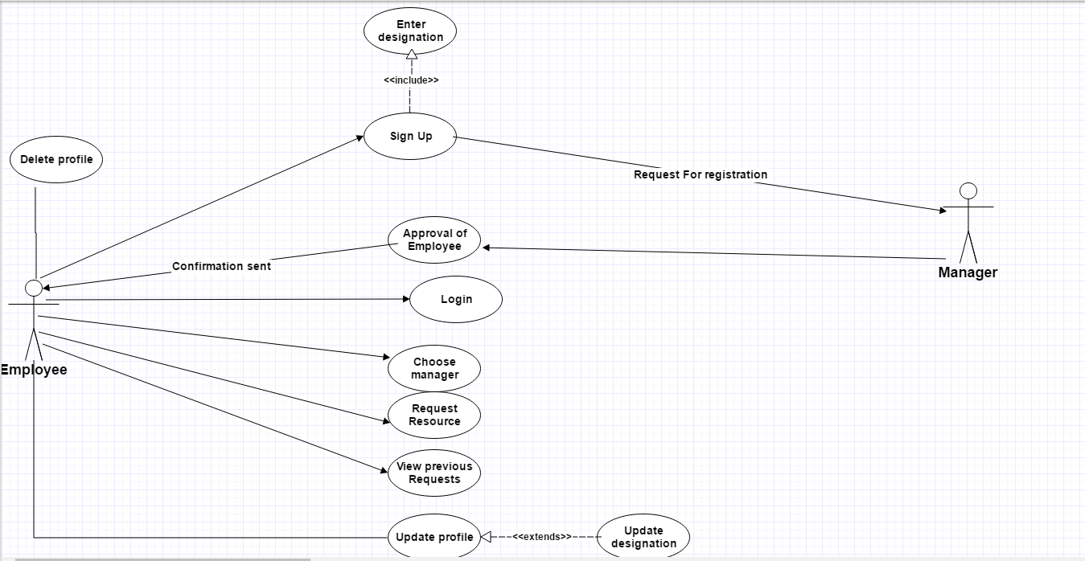
Detailed Description :

    - Sign Up :

Employee will be firstly sign up for registration in this portal.And he/she should be comulsory to add his/her designtaion.

    - Approval of employee :

Manager authenticate employee and send confirmation to employee.Now employee can login in portal.

    - Choose manager:

Employee can choose manager of his/her project.So that request for resources will be sent to that manager .

    - Request resource :

Employee can request for resources to manager.

    - View previous request:

Employee can see his/her previous resouce request and their status e.g-comitted,not fulfilled

    - Update profile:

Employee can update their profile -basic information/change designation/change manager.

    - Delete profile :

Employee can delete their profile in case of leaving from company/nor require resouces further.

